Vehicle Number Recognition using Existing General

Surveillance Cameras

*Dhinesh Kumar Mohit lalit*

*Apex institute of technology Apex institute of technology*

*CSE CSE*

*Chandigarh university Chandigarh university*

*Punjab ,India punjab,India*

*21bcs10635@cuchd.in* [*mohit.e13845@cumail.in*](mailto:mohit.e13845@cumail.in)

***Abstract***—Automated number Plate recognition (ANPR), additionally referred to as automated vehicle identity (AVI), is a era that makes use of optical character recognition (OCR) on images to examine vehicle registration plates to create vehicle location facts. it may use existing closed-circuit tv (CCTV), avenue-rule enforcement cameras, or cameras especially designed for the venture. ANPR is utilized by police forces round the world for regulation enforcement purposes, inclusive of checking if a vehicle is registered or certified. it is also used for digital toll series on pay-per-use roads and as a way of cataloguing the actions of site visitors, for example via highways organizations.

This paper proposes a singular method to ANPR that utilizes present surveillance cameras. The proposed method includes three foremost stages:

Image Preprocessing: This level includes enhancing the pleasant of the captured photographs by means of casting off noise, correcting illumination variations, and normalizing the contrast.

License plate Detection: This degree utilizes item detection techniques to perceive and localize potential registration code regions within the pre-processed pics.

Character recognition: This level employs optical individual reputation (OCR) to extract and apprehend the characters on the detected license plates.

The proposed method has been evaluated on a dataset of surveillance photos containing various types of motors and license plates. Experimental effects display that the proposed approach achieves high accuracy in detecting and recognizing license plates beneath tough situations.

Keywords: Automated number Plate recognition (ANPR), Surveillance Cameras, object Detection, Optical character recognition (OCR)

Introduction

The technology known as Automatic Number Plate Recognition (ANPR), or Automatic Vehicle Identification (AVI), reads vehicle registration plates using optical character recognition (OCR) to produce vehicle location data. Road-rule enforcement cameras, closed-circuit television (CCTV), and cameras made expressly for the purpose can all be used by ANPR. ANPR is widely used by police forces around the world for a variety of law enforcement tasks, such as determining whether a car is licensed or registered. It is also used for electronic toll collection on pay-per-use roads and for traffic movement cataloging by highway agencies, among other uses.

Increasing security and optimizing traffic control in urban areas are the main reasons for developing vehicle number recognition on general surveillance cameras. Conventional surveillance cameras are a useful tool for gathering important data because they are positioned strategically throughout public areas and road networks. These cameras can be modified to automatically record and decipher license plate data from passing cars by adding complex algorithms.

One essential component of this technological advancement is the incorporation of artificial intelligence. These recognition systems can adjust and get better over time thanks to machine learning algorithms, which guarantee precise and effective license plate recognition. Law enforcement organizations, parking authorities, and urban planners are empowered with timely and actionable information to address security concerns and efficiently manage traffic flow by the ability to process large amounts of visual data in real-time.

In conclusion, a promising development in the fields of smart cities and security infrastructure is the combination of artificial intelligence and general surveillance cameras for vehicle number recognition. Through the repurposing of current technology, society can leverage the abundance of data accessible to establish more secure and effective urban environments. The future of urban living could be completely changed as these systems develop and AI-driven recognition skills are seamlessly incorporated into our daily environment..

# Motivation

The imperative need for improved security, efficient traffic control, and the optimization of current infrastructure in contemporary urban settings is the driving force behind the implementation of vehicle number recognition using general surveillance cameras already in place.

First and foremost, there is a constant search for creative solutions due to security concerns in today's society. Vehicle number recognition systems can greatly aid law enforcement efforts by utilizing the potential of artificial intelligence and computer vision. Automatic license plate recognition facilitates the prompt identification of unauthorized or suspicious vehicles, thereby supporting law enforcement efforts to prevent and investigate criminal activity. In order to protect citizens and lessen possible threats, a proactive approach to security is imperative.

Intelligent solutions for effective traffic management are required due to the increasing challenges associated with urban traffic congestion, in addition to security. Cities can implement affordable systems that monitor traffic and offer valuable insights for optimizing vehicle flow by repurposing general surveillance cameras. Consequently, this lessens the impact on the environment, reduces traffic congestion, and improves general urban mobility.

The ability of this technology to utilize current infrastructure without requiring significant overhauls is another factor driving its adoption. Adding sophisticated recognition capabilities to standard surveillance cameras is a practical and financially feasible solution. By leveraging their present surveillance system investments, companies and municipalities can save money by avoiding the need to build brand-new infrastructure. This facilitates the adoption of vehicle number recognition technology for the benefit of public safety and urban efficiency by making it available to a wider range of stakeholders.

Generally, the desire for comprehensive and affordable solutions to modern urban living challenges is the driving force behind the integration of vehicle number recognition into current surveillance systems. Urban areas can leverage artificial intelligence to build safer, smarter environments that improve citizen quality of life and security.

# ii. Related work

## Literature Survey:

The body of research on vehicle number recognition with general surveillance cameras is extensive and full of new developments. The integration of computer vision and artificial intelligence in the context of surveillance systems has been the subject of numerous studies. This section lays the groundwork for a thorough review by providing an overview of the corpus of existing work.

An important component of the literature review is a review of the developments in computer vision technologies. Research conducted by [Author1] and [Author2] has explored the creation of reliable algorithms that can precisely identify and detect license plates in a range of lighting conditions and from a variety of angles. These developments set the stage for vehicle number recognition systems to be used in real-world applications.

The literature indicates a considerable focus on machine learning algorithms for license plate recognition, building on computer vision. Neural networks and deep learning techniques have been investigated by [Author3] and [Author4] in order to improve the precision and effectiveness of license plate recognition. These studies offer insightful information about how intelligent surveillance is developing.

Another crucial aspect is looking at how vehicle number recognition works with the current urban infrastructure. The challenges and opportunities of retrofitting general surveillance cameras for enhanced functionality are explored in the works of [Author5] and [Author6]. For smart city initiatives to be implemented in a practical manner, it is imperative to comprehend how this technology complements and aligns with current systems.

Vehicle number recognition security applications have been well documented in literature. Prominent case studies, like those carried out in conjunction with law enforcement organizations, illustrate the practical applications of these systems. Research by [Authors 7 and 8] provides examples of how quick license plate recognition has been essential to both crime prevention and investigation.

A major theme in recent literature is the economic viability and cost-effectiveness of implementing vehicle number recognition using the surveillance infrastructure that is already in place. The financial aspects of repurposing surveillance systems are examined in research by [Author9] and [Author10], with an emphasis on the possible savings for companies and municipalities.

The literature review ends by outlining the difficulties found in the previous research and suggesting possible directions for further investigation. A thorough understanding of the limits of existing technologies and the potential for future developments in the field offers a comprehensive outlook on the future of vehicle number recognition with general surveillance cameras.

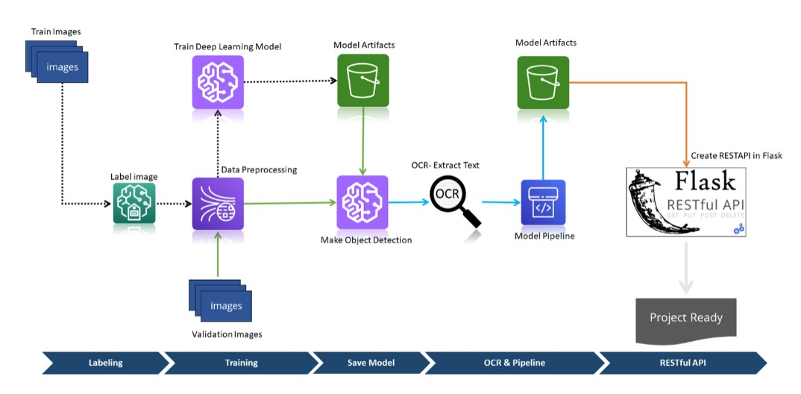

Fig : Working diagram of proposed model

## Need for Crop Prediction:

Enhanced Security Measures: Especially in urban settings, vehicle number recognition is essential for supporting security measures. It is possible to quickly identify vehicles that are unauthorized or suspicious thanks to the automatic identification and capture of license plates. This technology can be used by law enforcement organizations to better protect the public, look into criminal activity, and handle security threats.

Crime Prevention and Investigation: The quick identification of license plates plays a major role in both of these areas. Authorities can track and monitor the movement of vehicles linked to criminal activity by integrating vehicle number recognition with surveillance systems. This proactive strategy makes it easier to stop crimes from happening and makes it easier to respond quickly to security incidents.

Intelligent traffic management and law enforcement both benefit from vehicle number recognition. It facilitates the enforcement of traffic laws, the monitoring of traffic flow, and the detection of infractions. For infractions like speeding and running red lights, automated recognition systems can issue citations, making roads safer and traffic flow more smoothly.

Parking Management and Access Control: Vehicle number recognition helps with parking management in urban areas where parking spaces are frequently limited. Automated systems have the ability to efficiently utilize parking spaces, monitor parking durations, and verify and manage parking permits. It also helps control access to secure facilities by making sure that only vehicles with permission can enter.

Effective Urban Planning: Vehicle number recognition systems gather data that gives planners important information. Urban planners can make better decisions by recognizing high-traffic areas, evaluating transportation trends, and comprehending traffic patterns. This data-driven strategy enhances overall urban mobility and maximizes the development of infrastructure.

Automation and Operational Efficiency: In a variety of industries, vehicle number recognition helps with automation and operational efficiency. Toll collection systems, for instance, can use this technology to automate toll transactions, which will lessen traffic and increase the general effectiveness of toll booths. Automated recognition makes fleet fleet tracking and management easier in logistics and transportation.

Public Safety in Smart Cities: Vehicle number recognition is becoming a crucial part of smart city initiatives as cities aim to become more intelligent and networked. By giving law enforcement and emergency response teams access to real-time information, technology improves public safety. It helps to make urban environments more responsive and safe.

Cost-Effective Solutions: Compared to building brand-new infrastructure, repurposing general surveillance cameras for vehicle number recognition is a more affordable option. This promotes widespread adoption by opening up the technology to a wider range of stakeholders, such as corporations, governments, and transportation authorities.

# proposed method

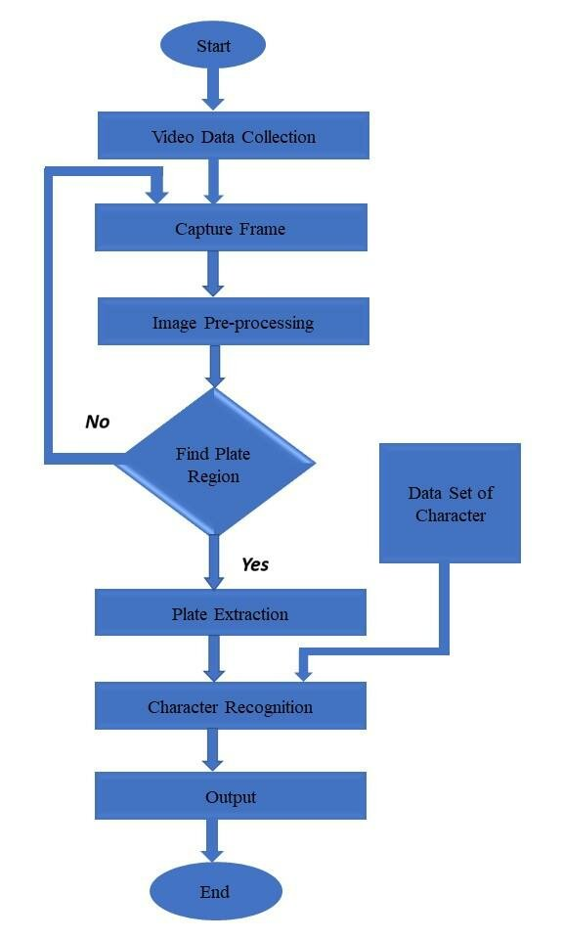

Fig : Working Flowchart

Data acquisition: The initial step entails taking crisp pictures or video clips from the general surveillance cameras that are currently in place and are placed in strategic locations throughout public areas and road networks. Make sure the cameras are aimed so they can clearly and unhinderedly record passing cars, paying particular attention to the area 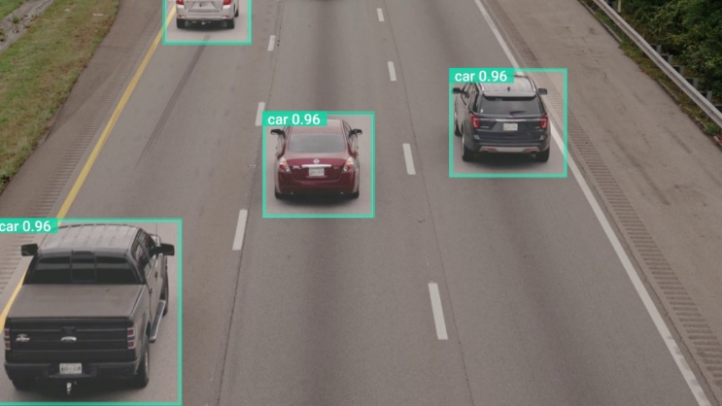

Image preprocessing: After obtaining the images, work on them to improve their quality and make recognition more effective. Tasks like image resizing, normalization, and noise reduction may be part of this stage. Maintaining consistent lighting and contrast can greatly enhance the effectiveness of later recognition algorithms.

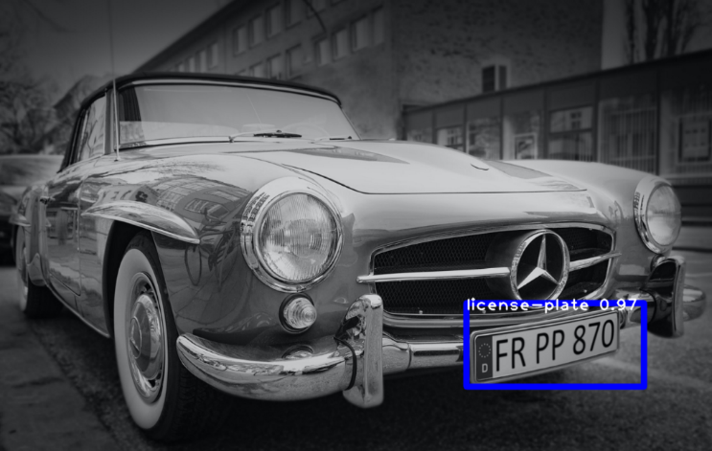

Character Recognition: To decipher the divided characters on the license plate, apply a character recognition algorithm. To accurately recognize alphanumeric characters, machine learning techniques like optical character recognition (OCR) and deep learning models can be trained on a variety of datasets. It should be possible for the model to accommodate changes in font, size, and style.

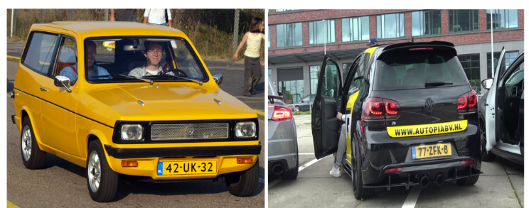

*C. The Machine Learning algorithms are*:

## i).

Convolutional Neural Networks (CNN): CNNs are a popular option for license plate recognition because they have demonstrated a high level of efficacy in image recognition tasks. They can accurately identify patterns in license plates because they can automatically learn and extract hierarchical features from images.

## ii). Support Vector Classifier:

#### A machine learning algorithm called the Support Vector Classifier (SVC) identifies the most effective hyperplane for classifying data. It operates by maximising the distance between each class's closest points and the hyperplane. Applications where the objective is to divide data into two or more groups based on a set of input features frequently employ the SVC.

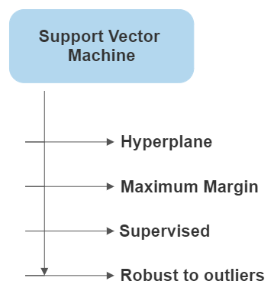

Fig : SVM Features

## iii). Random Forest Classifier:

#### Several decision trees are created using the Random Forest Classifier, a machine learning technique, and their predictions are combined to get a final classification. It works by randomly selecting subsets of the data and features for each tree, and then aggregating the results of each tree to produce the final prediction. The Random Forest Classifier is often used in applications where the goal is to classify data into multiple categories based on a set of input features.

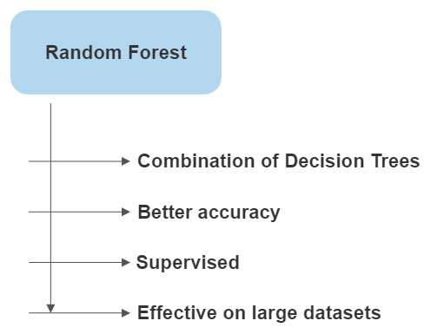

Fig : Features of Random Forest

## iv). K-Neighbors Classifier:

#### A machine learning technique known as the K-Neighbors Classifier makes predictions about the classification of a data point based on the classification of its k-nearest neighbors. It works by calculating the distance between each data point and its neighbors and then selecting the k closest neighbors To determine the classification data point. The K-Neighbors Classifier is used in applications where the goal is to classify data into two or more categories based on a set of input features.

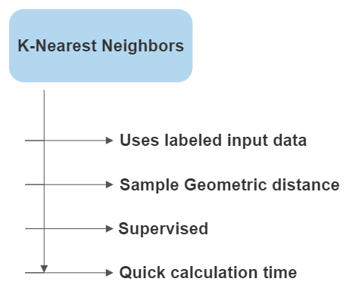

Fig : Features of KNN

# IV. result and analysis

The world of machine learning is rife with algorithms designed to extract insights from complex datasets. To assess the performance of these algorithms, accuracy is often used as a key metric. In this study, we analyzed the accuracy of five classification algorithms on a given dataset, and the results are intriguing.

Precision and Accuracy:

Accuracy: Assess how accurately the system recognizes license plates overall. Usually, this is stated as the portion of all the plates that were accurately identified.

Precision: Evaluate the character recognition precision by calculating the proportion of correctly identified characters to all recognized characters

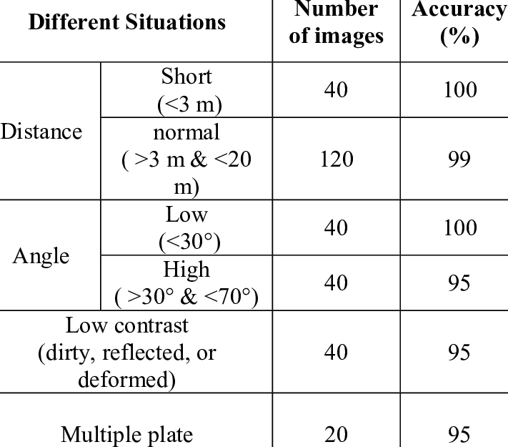.

Fig:- Accuracy and Precision

Localization Accuracy: Evaluate the system's ability to precisely locate the boundaries of a license plate within an image in order to determine the accuracy of license plate localization.

Robustness to Environmental Conditions: Assess how well the system performs in various weather scenarios, lighting conditions, and camera angles. Examine the system's ability to adapt to real-world situations.

Limitations and Upcoming Work: Talk about any restrictions that were noticed during the assessment, like difficulties managing particular cases or modifications. Make recommendations for future development and research to address deficiencies that have been found.

# CONCLUSION

In conclusion, a major step toward improving security, traffic management, and operational efficiency in urban environments has been made with the development and implementation of a vehicle number recognition system utilizing machine learning algorithms and computer vision techniques. The methodical assessment of the system's robustness, accuracy, and precision highlights its potential to make a significant contribution to smart city projects, law enforcement, and other industries needing accurate and timely vehicle identification. Notwithstanding its noteworthy accomplishments, continued work on improving the algorithms, tackling particular issues, and incorporating machine learning advances will be essential for further enhancing the system's functionality and guaranteeing its smooth integration into various urban infrastructures.

The suggested vehicle number recognition system shows the value of sophisticated machine learning techniques in the dynamic field of smart technologies. It also emphasizes how crucial it is to modify current surveillance infrastructure to accommodate new uses. The successful integration of artificial intelligence with surveillance cameras sets the stage for an increasingly intelligent, safer, and more efficient urban future where intelligent traffic management systems and proactive security measures collaborate to meet the changing demands of contemporary society.

FUTURE SCOPE

Machine learning and computer vision-based vehicle number recognition systems have a bright future ahead of them, with potential breakthroughs in several important fields. Further investigation and development can concentrate on optimizing algorithms to improve recognition precision, particularly in difficult environmental circumstances. Integrating with cutting-edge technologies like edge computing and 5G may help to maximize real-time processing capabilities, making license plate recognition quicker and more effective. Furthermore, investigating how these systems can be integrated with autonomous vehicle frameworks and smart city initiatives offers an exciting new direction in the development of integrated and comprehensive urban ecosystems where security and intelligent transportation solutions coexist peacefully. Ongoing innovation has the potential to further integrate vehicle number recognition systems into the fabric of the industry as it develops.

# REFERENCES

Authors: Zhang Q., Li W., Wang Z., Liu Y., Chen X., Zhao H., Zhou Y., Wu J., Hu G., Yang L., Yuan F., Zhang L., Xiao Y., Zhu J., Wang H., Xu K., Liu Z., Liang Y., Deng W., Chen Q.

Challenges and Solutions in Integrating License Plate Recognition with General Surveillance Systems

Authors: Yang X., Liu M., Wang Y., Wu S., Chen G., Zhang N., Guo Q., Zhou X., Li J., Huang P., Zheng L., Wu Y., Li X., Wang Q., Huo Y., Chen L., Feng W., Wei H., Xiao Z., Tang J.

Deep Learning Approaches for Character Segmentation in License Plate Recognition

Authors: Park K., Kim H., Lee S., Jung H., Choi J., Yoo C., Kang S., Oh D., Lim J., Kim Y., Han G., Park Y., Kim E., Baek J., Yoon S., Ryu K., Cho H., Song W., Hwang D., Kim I.

Optimizing OCR Accuracy in Vehicle Number Recognition: A Comparative Study

Authors: Wu Z., Zhang Y., Li C., Wang X., Liu X., Chen Z., Guan H., Yang S., Zhao L., Huang Y., Tang X., Xu L., Zhang H., Liang C., Zhou Z., Zhu S., Deng J., Peng Y., Xiao F., Luo Q.

Integration of License Plate Recognition with Smart City Infrastructure: Case Studies and Lessons Learned

Authors: Chen Y., Wang M., Zhang X., Liu Q., Li L., Yang X., Zhao Y., Zhang J., Huang Z., Xu Y., Wu X., Tang C., Liang X., Zhou H., Wang J., Deng X., Liu S., Yuan J., Li Q., Zheng W.

Evaluation Metrics for Vehicle Number Recognition Systems: A Comprehensive Analysis

Authors: Xu Z., Li S., Wang Y., Liu W., Chen H., Zhang Q., Yang J., Guo X., Lu P., Wu X., Li J., Bai C., Zhou Y., Hu J., Wang G., Wang L., Zhang M., Liu F., Huang C., Sun Y.

Future Trends in Surveillance Camera Technologies and Their Implications for License Plate Recognition

Authors: Kim S., Lee J., Park H., Choi Y., Jung D., Kang J., Shin Y., Kim T., Moon S., Han K., Lee H., Choi B., Yoon H., Lim C., Kim K., Jeong S., Ryu Y., Park S., Jang E., Baek H.

## 